**Agricultural Decision Support System (ADSS)**

AGRARIAN delivers an integrated digital platform that supports decision-making in real agricultural environments across **crop, viticulture, and livestock** management. The project’s technical solution is built around an **Agricultural Decision Support System (ADSS)** that connects multiple data sources—**in-field sensors**, **open data services (e.g., weather)**, and **drone-based monitoring** where applicable—organizes them into a consistent data layer and presents the results through a practical front-end designed for day-to-day use.

AGRARIAN addresses a common challenge in agriculture: critical information is often fragmented across isolated tools, while decisions must be taken quickly under changing field, biological and weather conditions. By bringing **monitoring, forecasting, simulations and guidance** into a single interface, the platform helps users understand current conditions, anticipate risks and act with greater confidence and traceability.

**ADSS Architecture and Data Flow**

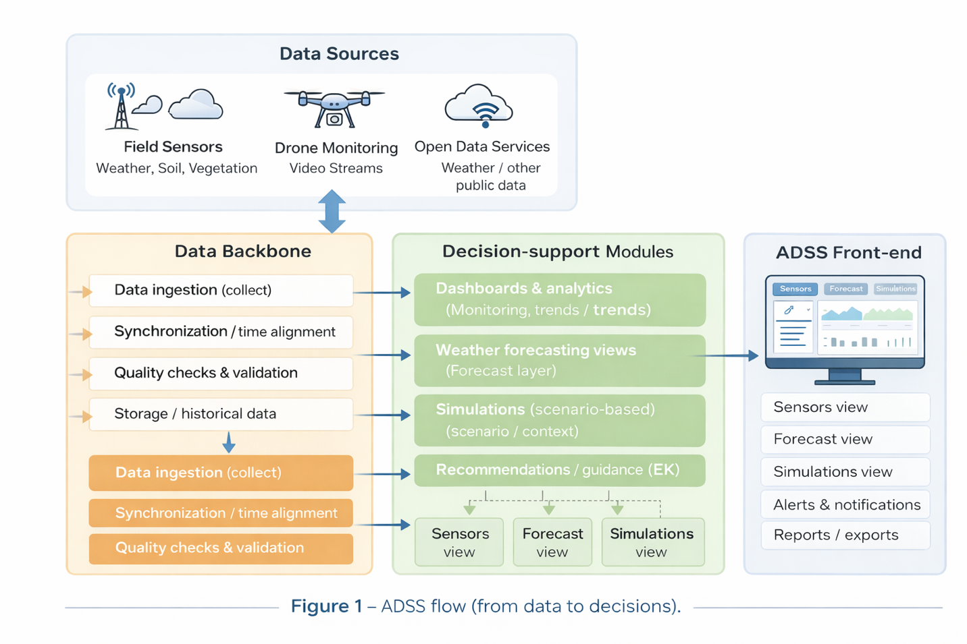

*Figure 1 – ADSS Flow: From Data to Decisions*

The platform begins by collecting information from in-field sensors, open data sources (such as weather services), and drone-based monitoring where applicable. These inputs are ingested into a **common data layer**, synchronized in time and space and quality-checked to ensure consistency and reliability. The system builds a historical record that supports trend analysis and model-based processing.

On top of this foundation, the ADSS generates **forecast-based insights** and **scenario-driven simulation outputs** that support planning and risk awareness. Results are delivered in the front-end as clear dashboards, alerts, and decision-support views, enabling users to move efficiently from monitoring and analysis to informed operational action (Figure 1).

**Key functionalities**

1) Sensor data collection and historical monitoring The platform connects to field stations and sensors and centralizes measurements by site. Users can view current conditions and historical trends in clear charts, track how indicators evolve over time, and quickly identify changes or anomalies. This replaces scattered device-level views with one consistent monitoring experience, supporting both daily checks and longer-term evaluation.

2) Weather forecast views (open sources) ADSS integrates weather information from open sources to complement measured field data with forward-looking insights. Forecast views support planning by helping users anticipate upcoming conditions, understand how weather may influence operations, and identify safer time windows for actions that depend on weather stability.

3) Alerts and simulations based on scenarios A dedicated area supports alerts and scenario-based simulations. Users can run simulations based on the context relevant to the pilot (site/station and other parameters) and review structured results that support risk awareness and planning. Outputs are displayed in an operational format—such as result panels, guidance cards, or alerts—so insights can be interpreted quickly and translated into action. Pilot validation Testing and validation of the platform are performed through three pilots, deployed in different operational contexts and geographical areas. Each pilot focuses on specific capabilities while validating the common platform backbone (data ingestion, dashboards, forecasting views, simulations, and guidance). (Figure 2)

**Pilot validation**

Testing and validation of the platform are performed through **three pilots**, deployed in different operational contexts and geographical areas. Each pilot focuses on specific capabilities while validating the common platform backbone (data ingestion, dashboards, forecasting views, simulations, and guidance). (Figure 2)

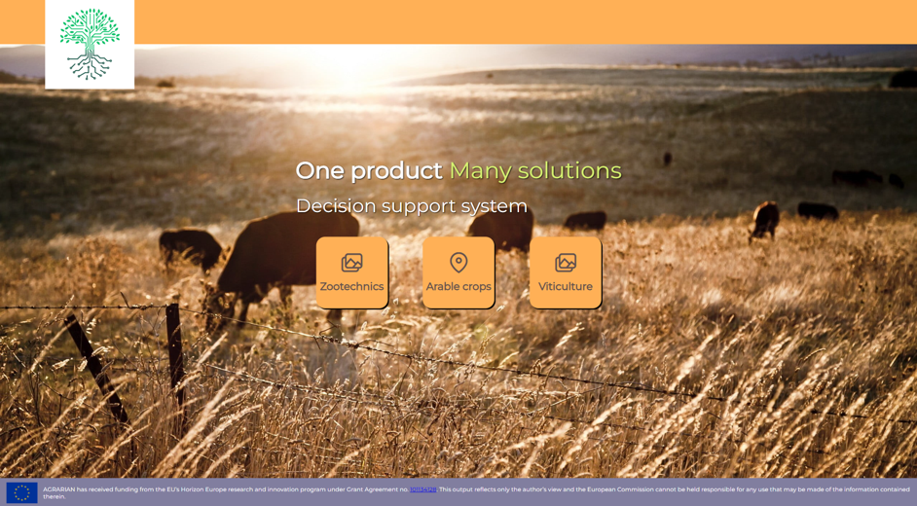

*Figure 2 – ADSS Homepage*

**Pilot 1 — Arable Crops (sensor + forecast + simulations)**

This pilot validates the full decision-support workflow for crop production. It focuses on how well the platform can centralize field measurements, combine them with weather information, and provide simulation outputs that help users plan key activities. (Figure 3)

* **Monitoring:** station-based dashboards showing sensor values and trends over time, supporting day-to-day awareness and seasonal tracking
* **Forecast:** integrated weather views to support planning and timing of operations
* **Simulations:** scenario-based outputs designed to support practical decisions (for example, sowing timing, pest risk awareness, and irrigation-related needs, depending on the configured simulations)
* **Decision support in the interface:** results presented in a structured way (cards/panels/alerts) so users can interpret them quickly and act

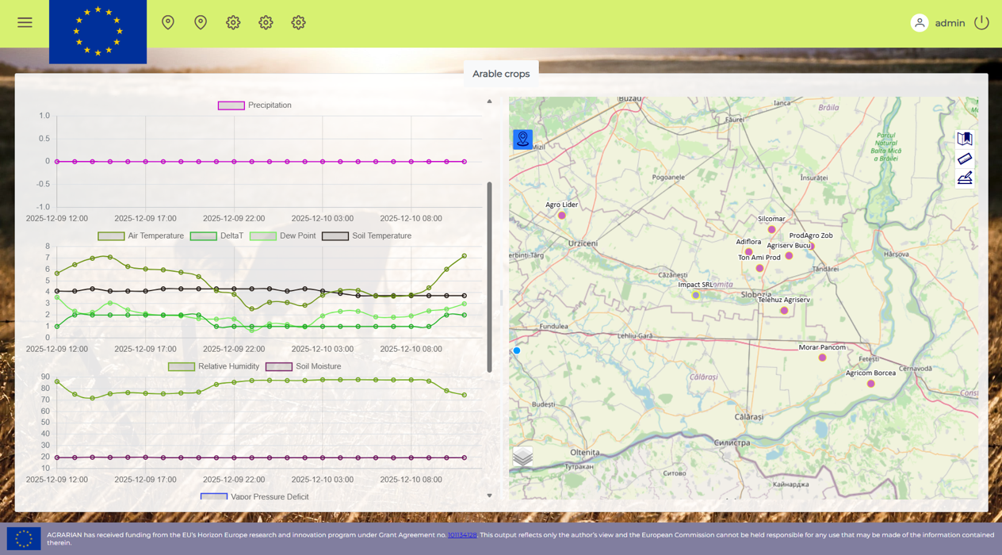

*Figure 3 – ADSS Pilot 1 Interface – Arable crops*

**Pilot 2 — Zootechnics (drone supervision for sheep/goats)**

This pilot validates drone integration and livestock supervision workflows in a single platform interface. The focus is on providing aerial visibility and actionable detection outputs for operators working with herds. (Figure 4)

* **Drone streaming:** access to live streams and/or recordings directly in the platform
* **Detection outputs:** identification/localization of animals (sheep/goats) and event-oriented outputs supporting supervision
* **Notifications:** alerts linked to detected situations, supporting faster response and better situational awareness
* **Unified experience:** drone monitoring is available alongside the platform’s common views and reporting, ensuring consistency across use cases

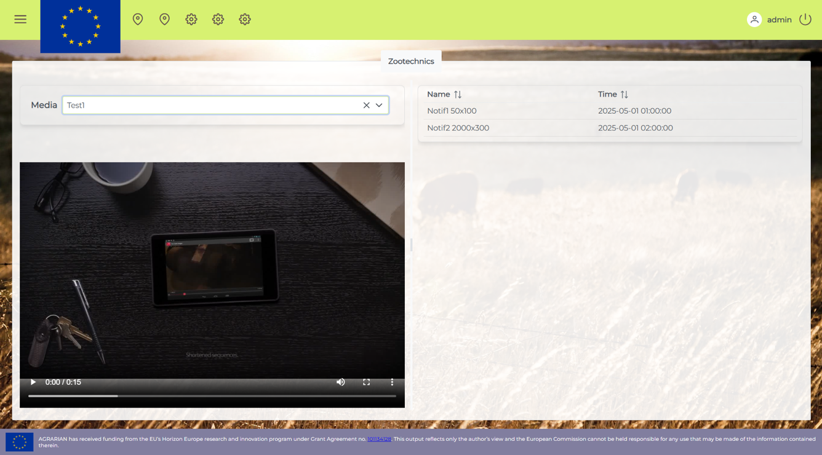

*Figure 4 – ADSS Pilot 2 Interface –Zootechnics*

**Pilot 3 — Viticulture (vineyard monitoring + maturity/sweetness forecasting)**

This pilot validates ADSS in a vineyard context, focusing on monitoring conditions relevant to vine development and on forecasting views that support planning decisions in the run-up to harvest.

* **Monitoring:** vineyard station dashboards showing vegetation/microclimate-related conditions and their evolution over time
* **Forecast:** weather views supporting operational planning and risk awareness
* **Grape maturity/sweetness forecasting (where configured):** forward-looking views that support timing decisions and harvest planning
* **Reporting/export:** data export options that allow further analysis and documentation when needed

**Cross-Cutting Technical Aspects (Common to All Pilots)**

* **Scalability and extensibility:** Modular architecture allowing new sensors, data sources, and models to be integrated over time
* **Data reliability:** Quality checks, synchronization mechanisms, and historical data management
* **User roles and access:** Role-based access to views and functions, aligned with operational responsibilities
* **Interoperability:** Support for standard data formats and APIs to facilitate integration with external systems
* **Decision traceability:** Historical records of data, forecasts, and simulation outputs to support review and learning